**Excel Assignment – 9**

1. What are the different margins options and do we adjust the margins of the excel worksheet?

To better align an Excel worksheet on a printed page, we can change margins, specify custom margins, or Center the worksheet—either horizontally or vertically on the page.

2. Set a background for your table created.

On the Page Layout tab, in the Page Setup group, click Background. Select the picture that you want to use for the sheet background, and then click Insert.

3. What is freeze panes and why do we use freeze panes? Give examples.

Simply, if we have a large table of data in Excel, it can be useful to freeze rows or columns. This way you can keep rows or columns visible while scrolling through the rest of the worksheet.

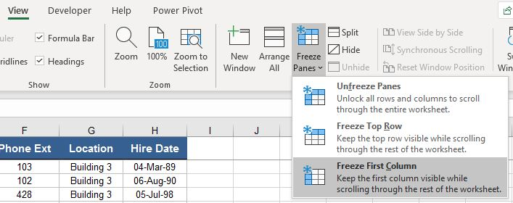

4. What are the different features available within the Freeze Panes command?

Excel enables three methods to freeze the pane.

1. Freeze Pane
2. Freeze Top Row
3. Freeze First Column

5. Explain what the different sheet options present in excel are and what they do?

There are multiple core options to perform from the Sheet Options. We can access various sheet options by using the following ways:

Ribbon Sheet Options

Right-click Sheet Options

Excel has all the basic and advanced options present on its ribbon. Likewise, some quick sheet options are also present on the Excel ribbon and can be accessed by going to Page Layout > Sheet Options. It mainly has four toggle options: two for Gridlines and two for Headings, and they can be turned on and off by selecting and deselecting the checkboxes.

In Excel, the right-click with mouse button usually displays the context menu for the selected element. When we press the right-click on any Sheet tabs, Excel displays a list of options relevant to Excel sheets. The list includes various sheet options. However, this list is usually called the 'worksheet menu'.